**PROJECT REPORT TEMPLEATE**

**IMPLEMENTING CRM FOR RESULT TRACKING OF A CANDIDATE WITH INTERNAL MARKS**

**TEAM ID : NM2023TMID20821**

**1.INRODUCTION**

**1.1 Overview :**

Administrator should be able to create all base data including semester, Semester, candidate, is one of the lecture, should be the only one with ability to update internal its , Re-evaluation can be initialised by candidate for all internal results . Now dean can update the marks after re- evaluation .

**1.2 Purpose :**

* Marketing campaign management
* Resolving conflicts
* Performance Appraisal
* Training & Development
* Maintaining Healthy Work culture
* Organizing various activities
* Payroll Management .

**2. Problem Definition & Design Thinking**

**2.1 Empathy map** :

 An empathy map is a collaborative visualization used to articulate what we know about a particular type of user. It externalizes knowledge about users in order to

1) create a shared understanding of user needs, and

2) aid in decision making

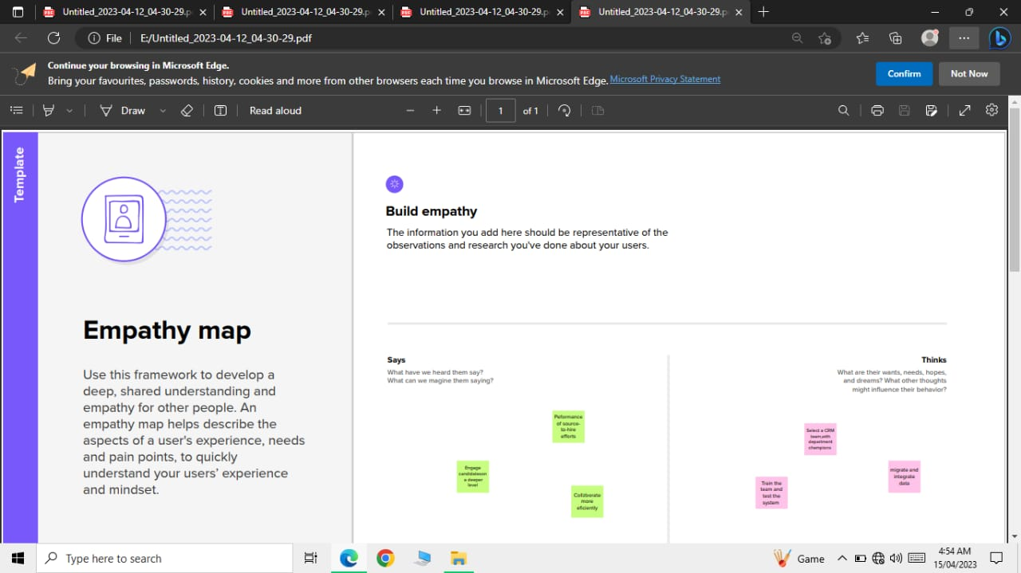

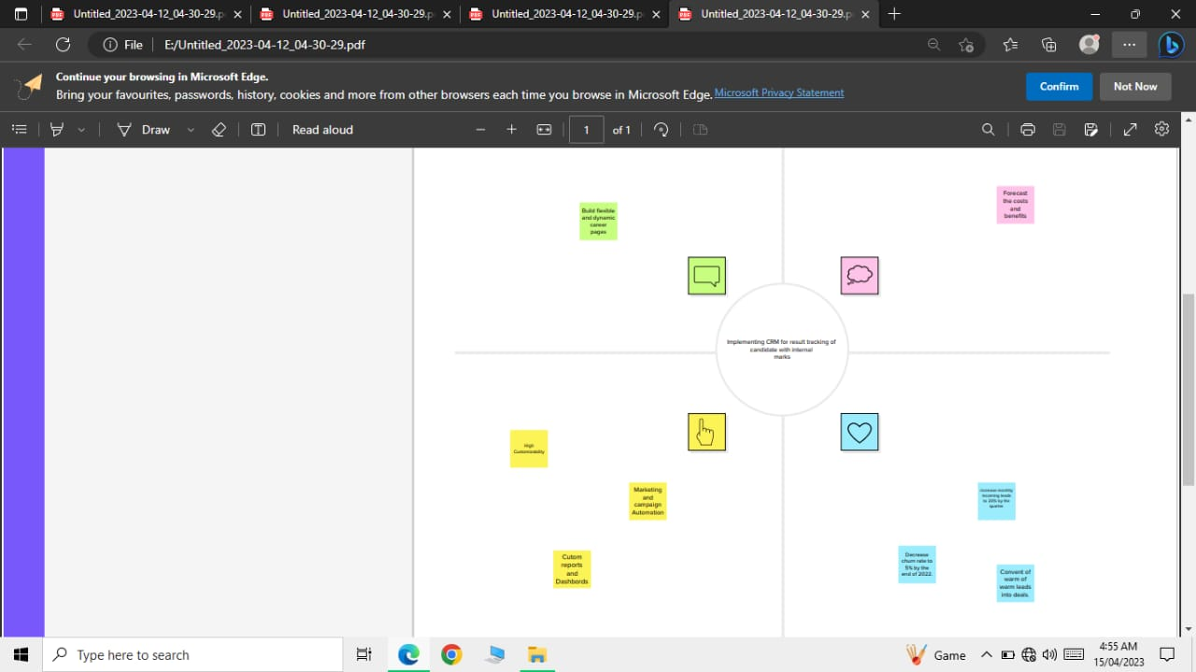

**2.2 Brainstorming :**

Brainstorming is a group problem-solving method that involves the spontaneous contribution of creative ideas and solutions. This technique requires intensive, freewheeling discussion in which every member of the group is encouraged to think aloud and suggest as many ideas as possible based on their diverse knowledge.

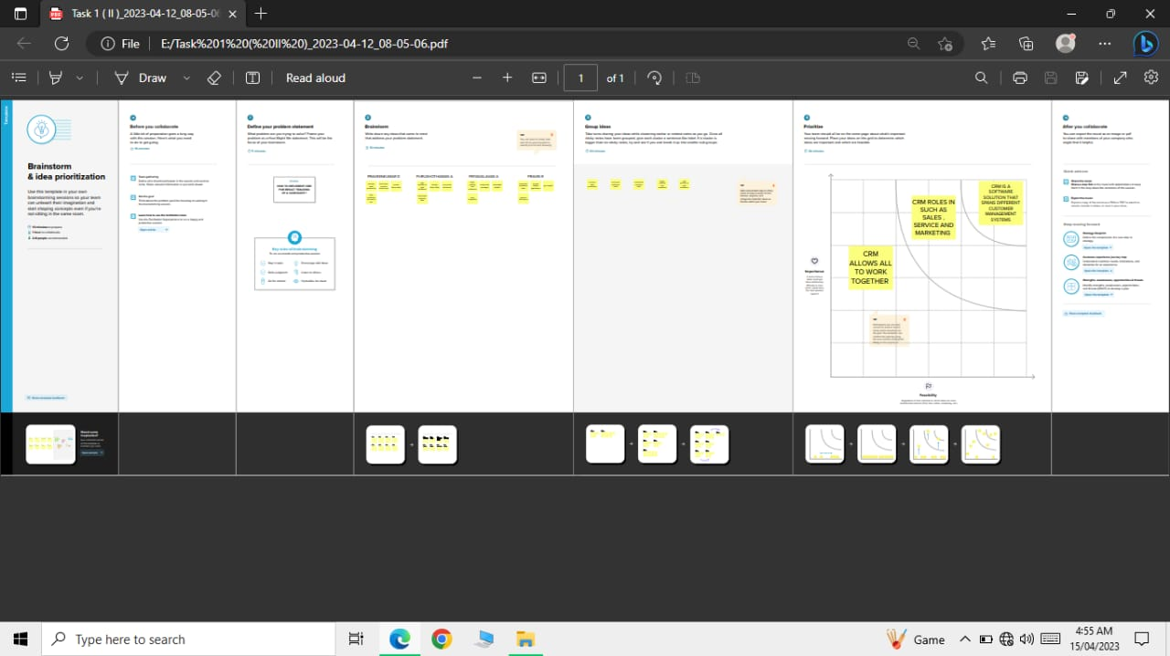

**3. RESULT**

**3.1 Data Model :**

|  |  |  |  |
| --- | --- | --- | --- |
| Object name | | Field label | Data type |
| **1** | Semester | Semester | Text |
| Candidate | Candidate | Text |
| **2** | Course Details | Course Details | Text |
| Internal Results | Internal Results | Text |

**3.2 Activity & Screenshort :**

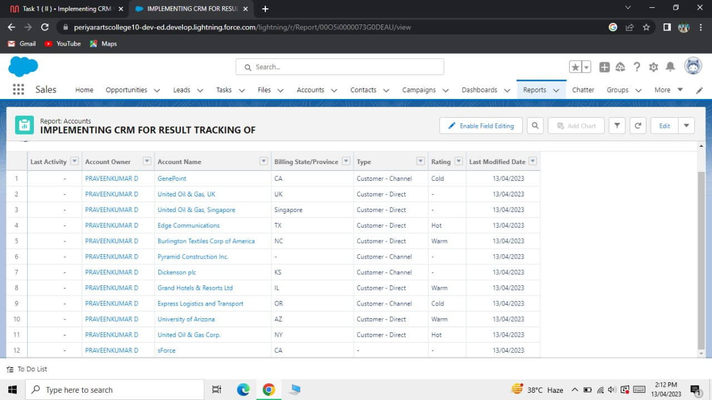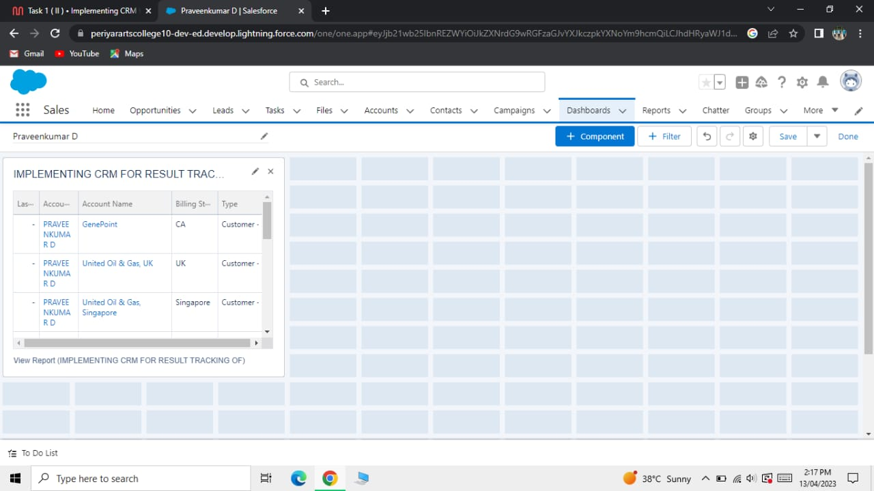

**4. TRAILHEAD PROFILE PUBLIC URL**

Team Leader – <https://trailblazer.me/id/pravd20>

Team Member 1 - <https://trailblazer.me/id/ppravin13>

Team Member 2 - <https://trailblazer.me/id/purua1>

Team Member 3 – <https://trailblazer.me/id/ppriyavalavan>

**5. ADVANTAGES & DISADVANTAGES**

**Advantages :**

The advantages of a business of using a CRM system greatly outweigh the disadvantages. However, there are pitfalls. For a CRM system to work, there needs to be buy-in across the organization and the processes in place to support it. Otherwaise, your CRM may end up being an expensive waste of time. Here,we take a look at the stratehic pros, cons, and importance of CRM.

**Disadvantages :**

We looked at the pros-the advantages-of initating a CRM system, so now its time to examine some of the cons—the disadvantages—of a CRM system. Whilst ultimately these are fewer in number then the advandages, for some businesses, the short—term pain of a cultural and technological shift can be a lot to bear and may not generate a return.

**6. APPLICATIONS**

* Trustworthy reporting
* Dashboards that visually showcase data
* Improved messaging with automation
* Proactive service
* Efficiency enhanced by automation
* Simplified collaboration

**7. CONCLUSION**

CRM implementation is a project that requires preparation, commitment and cooperation across the entire organization.There are a lot of things you need to get ready for, such as allocating resources, getting people onboard, rolling out a clear and consistent plan of action, etc.

But most importantly, you need to get ready for a shift in the mindset, as a CRM system may transform the way you do business.

**8. FUTURE SCOPE**

The project has a very vast scope in future . The project can be implemented on internet in future.